# Create MTA Project and Database Artifacts as part of DB Module

# Purpose – The main purpose of this document is to demonstrate the steps of createing a MTA Module project and later adding a db module using SAP Cloud Platform Full Stack Web IDE.

# Open SAP Full Stack Web IDE and a new project needs to be created by clicking on "File" -> "New" -> "Project from Template".

# exercise1

# A new dialog appears to select project template. Select the template "Multi-Target Application Project" and click on the "Next" button. On the next page enter the project name 'CPL166MTA' and click "Next".

# exercise1

# In the next step make sure to select DEV or development as the space and then finish the wizard.

# This will now create the project structure in your workspace.

# exercise1

1. Now that we have an MTA application project skeleton ready, we can add our first module which will contain the database content of the application. This module can be created by right-clicking on the project folder in the workspace (name **CPL166MTA**) and selecting "New" -> "SAP HANA Database Module". You might need to click on 'More...' to see this option.

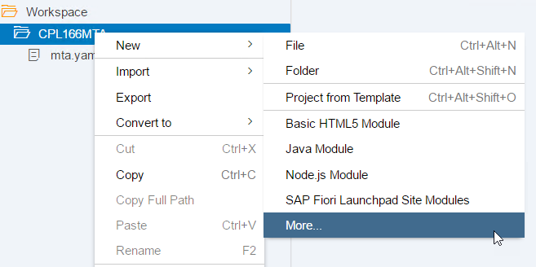

1. In the dialog enter the name of the module cpl166db and select HANA Database Version 2.0 SPS00! And click on "Finish".

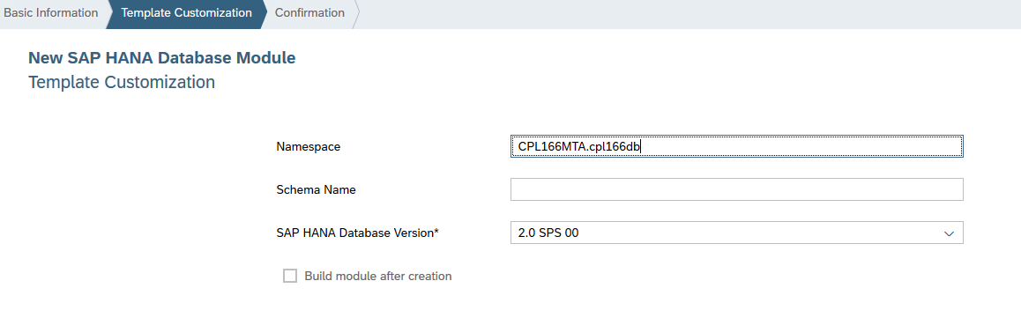

1. As a next step we will now add some basic database content. To create a CDS file, navigate to the src/ subfolder of the cpl166db module, right-click it and select "New" -> "CDS Artifact".

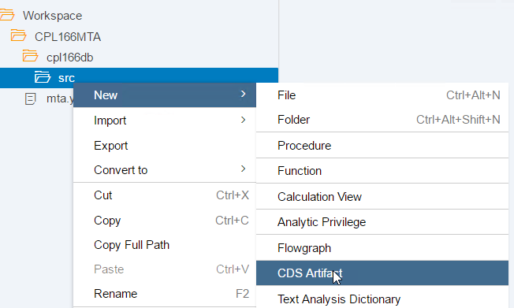

1. Enter the name cpl166f in the name field, set "Open With" to "Text Editor" and create the file.

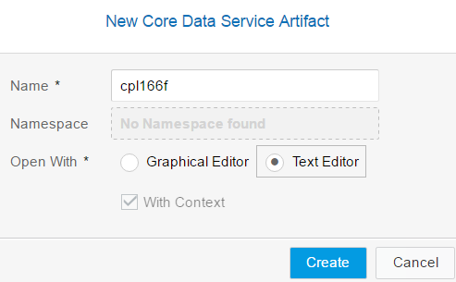

1. Right-click the created CDS file and select "Open-With" -> "Code Editor". Here we will define two entities, world and country and the relationship between them. Use the following code to define entity 'world' in the text editor as follows:

*namespace CPL166MTA.cpl166db;*

*context cpl166f {*

*entity world {*

*key continent : String(100);*

*}*

*};*

1. Open the graphical editor by right-clicking on the file cpl166f.hdbcds and selecting "Open With" -> "Graphical Editor":

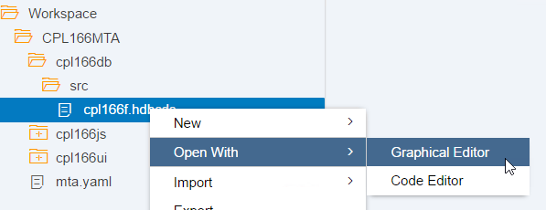

1. Create the next entity by clicking on Create Entity icon. Click on the icon and place it by moving the mouse on the canvas and left-click to complete. Now enter the name **country**.
2. Open the details view by double-clicking on **country.** Now add a new element by clicking on the '+' icon. Name the element name and select the data type String with a length of 100. Tick the key checkbox to set the name as key.

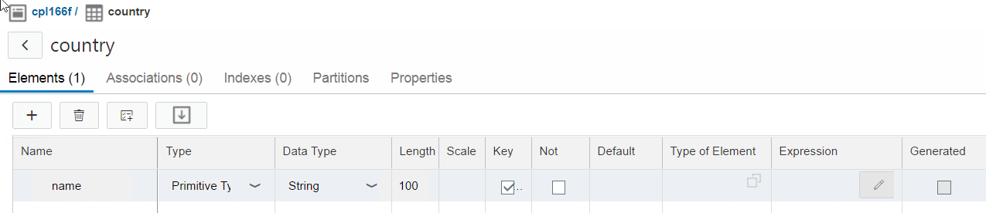

1. Model the relationship of the entities **country** and world switch to the 'Associations' tab and add a new association by clicking on the **'+'** icon again. Enter **partof** as name, select the Target Cardinality [0..1], Target Entity **world** and the Association Type Managed. Save the file by pressing CRTL+S and close the detail view by clicking on the < icon on the top-left.

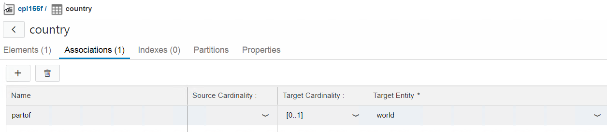

1. The graphic will now show the new entity and the association (depicted by the arrow connecting the entities).

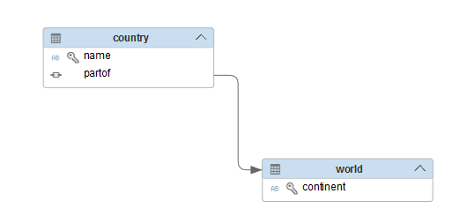

1. Select the **cpl166db** module🡪right-click🡪select "Build" to trigger the build process which creates the database artifacts required for the next steps.

**Create a Calculation View to introduce filter condition**

In this step we will leverage the analytic capabilities of SAP HANA to create a view that only shows the countries of the continent Europe. We will use the SAP HANA modeler to graphically create a Calculation View.

1. To create a Calculation View, navigate to the src/ subfolder of the cpl166db module, right-click and select "New" -> "Calculation View". In the upcoming wizard, enter the name **european_countries** and select the data category "**Dimension**". Then click "Create".

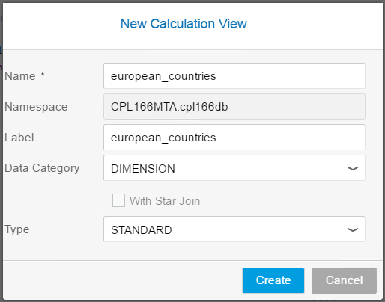

1. This will open the graphical editor for Calculation Views.

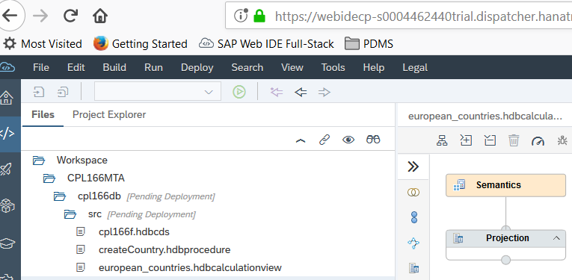

1. Here we will add a second projection underneath the already existing one by clicking the respective icon in the toolbar and place it by moving mouse to an empty space below the existing projection and draw a relation by using the arrow button which is visible when you select the new projection.

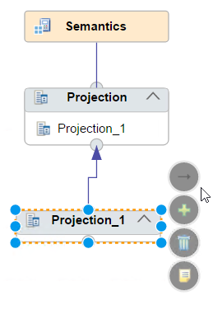

1. Select the **projection_1** node and click on the **+** icon on the "**Mapping**" tab on the right side of the editor and enter the search term "cpl". From the result, select **CPL166MTA.cpl166db::cpl166f.country** and click on "Ok". Now we need to *connect* the "Data Sources" to the "Output Columns": select the table and click on the "Add to Output" icon.

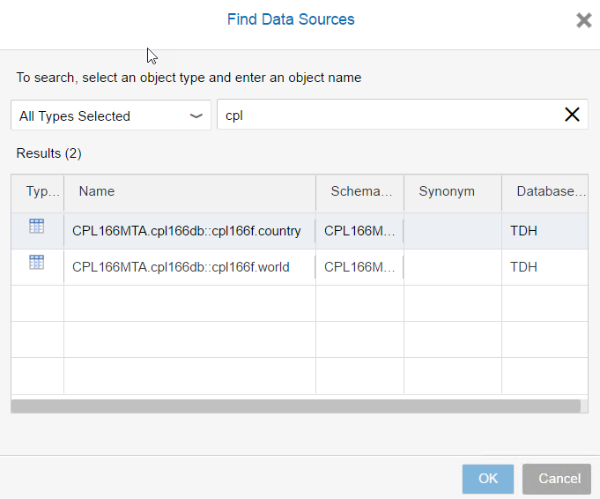

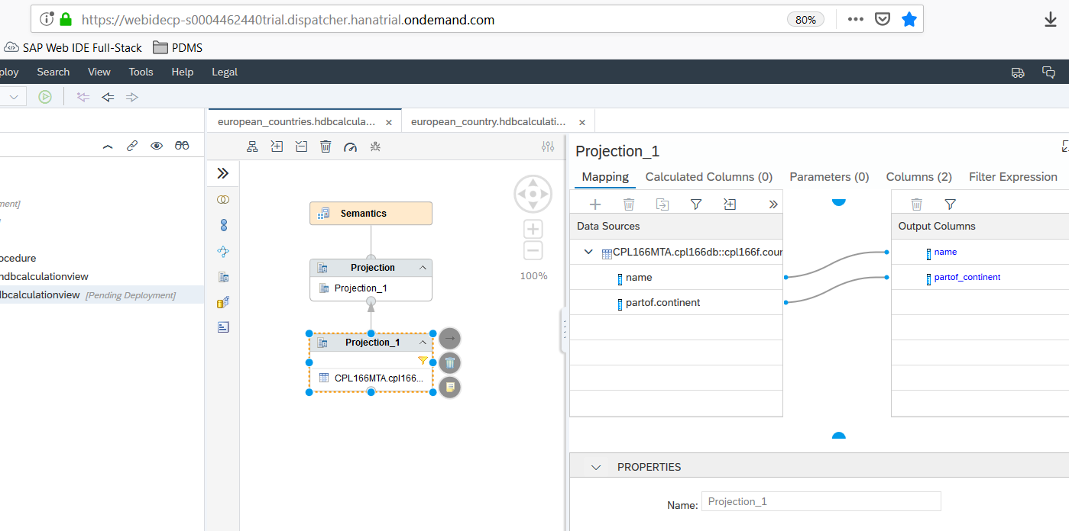

1. To create a "Filter Expression" to filter for countries in Europe. Navigate to the respective tab, open the "Columns" element and then double-click on **partof_continent**. In the operators selector click on the = button. The expression will appear at the top; complete it by typing 'Europe'.

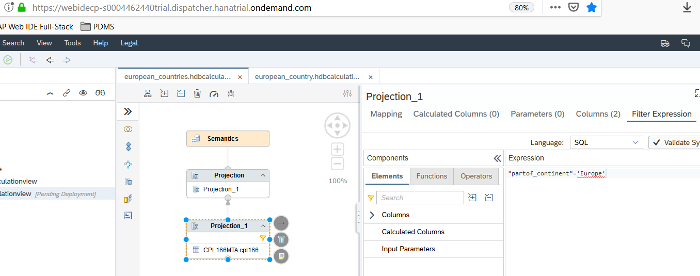

1. Next, select the **Projection** node on the left, and in its **Mapping** tab, select and drag name from "**Data Sources**" to "**Output Columns**" with your mouse.

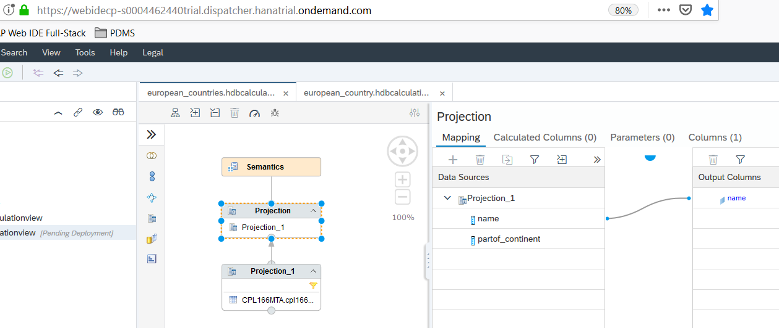

1. Finally save the Calculation View by pressing CTRL+S or pressing the save button.
2. Next, we will create a stored procedure written in SQLScript to create new records for country. The stored procedure can be created by right-clicking on the src folder inside the **cpl166db** module and selecting "New" -> "Procedure". We call our new procedure **createCountry**. Add the following content and save the file by pressing CTRL+S.

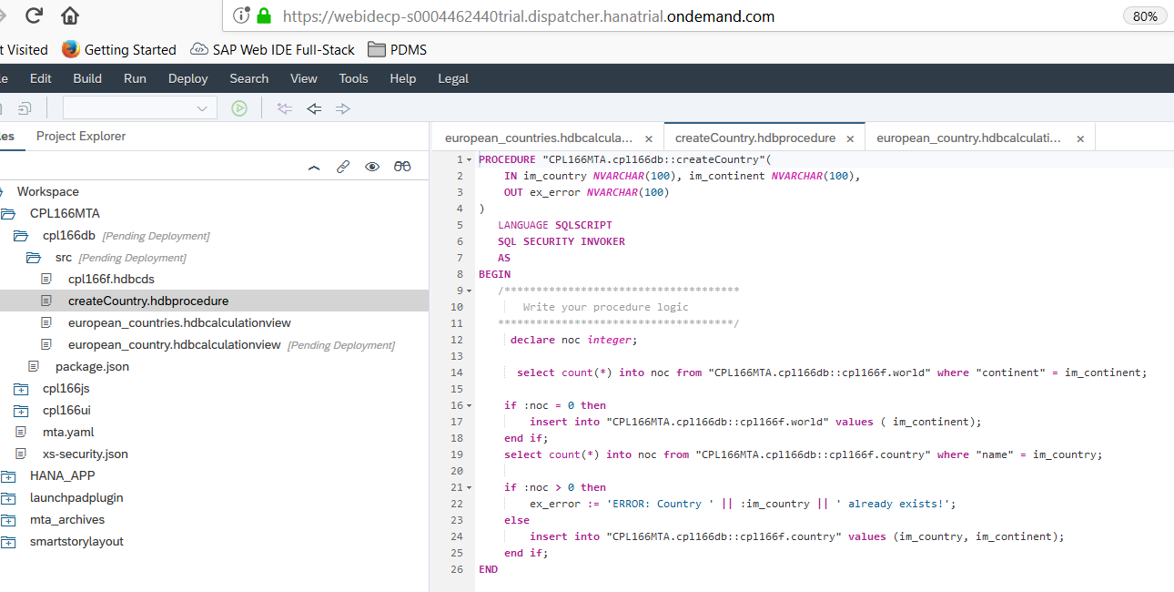

*PROCEDURE "CPL166MTA.cpl166db::createCountry"(*

*IN im_country NVARCHAR(100), im_continent NVARCHAR(100),*

*OUT ex_error NVARCHAR(100)*

*)*

*LANGUAGE SQLSCRIPT*

*SQL SECURITY INVOKER*

*AS*

*BEGIN*

*/\*\*\*\*\*\*\*\*\*\*\*\*\*\*\*\*\*\*\*\*\*\*\*\*\*\*\*\*\*\*\*\*\*\*\*\*\**

*Write your procedure logic*

*\*\*\*\*\*\*\*\*\*\*\*\*\*\*\*\*\*\*\*\*\*\*\*\*\*\*\*\*\*\*\*\*\*\*\*\*\*/*

*declare noc integer;*

*select count(*) into noc from "CPL166MTA.cpl166db::cpl166f.world" where "continent" = im_continent;*

*if :noc = 0 then*

*insert into "CPL166MTA.cpl166db::cpl166f.world" values ( im_continent);*

*end if;*

*select count(*) into noc from "CPL166MTA.cpl166db::cpl166f.country" where "name" = im_country;*

*if :noc > 0 then*

*ex_error := 'ERROR: Country ' || :im_country || ' already exists!';*

*else*

*insert into "CPL166MTA.cpl166db::cpl166f.country" values (im_country, im_continent);*

*end if;*

*END*

1. Select the **cpl166db** module🡪right-click🡪select "Build" to trigger the build process which creates the database artifacts required for the next steps.
2. Switch to the "Database Explorer" perspective of the WebIDE by clicking on the respective icon in the left sidebar. Expand the container by clicking on the small arrow. The UI shows the contained database artifacts in several categories. Select the "**Tables**". In the lower part, the newly created tables **CPL166MTA.cpl166db::cpl166f.world** and **CPL166MTA.cpl166db::cpl166f.countries** are shown.

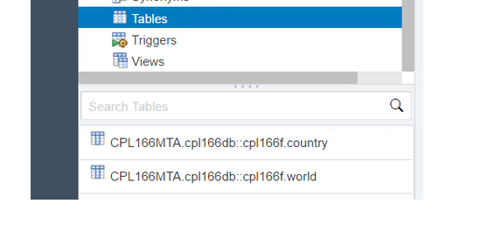

1. To insert data, we will use following SQL-Insert statements to create the continents and Call statements to create the countries. The SQL-Insert statements can be run together, the Call statements need to be run individually because they contain variables.

INSERT INTO "CPL166MTA.cpl166db::cpl166f.world" VALUES('Europe');

INSERT INTO "CPL166MTA.cpl166db::cpl166f.world" VALUES('Asia');

CALL "CPL166MTA.cpl166db::createCountry"('Spain', 'Europe', ?);

CALL "CPL166MTA.cpl166db::createCountry"('Japan', 'Asia', ?);

CALL "CPL166MTA.cpl166db::createCountry"('Denmark', 'Europe', ?);